Chapter-4 | Lipids | Biochemistry and

Clinical Pathology

Lipids
- Definition, classification with examples
- Structure and properties of triglycerides (oils and fats)
- Fatty acid classification - Based on chemical and nutritional requirements with examples
- Structure and functions of cholesterol in the body
- Lipoproteins - types, composition and functions in the body
- Qualitative tests and functions of lipids

Lipids
Definition—The lipids are a heterogeneous group of compounds, including fats, oils, steroids, waxes, and related compounds, that are related more by their physical than by their chemical properties. They have the common property of being (1) relatively insoluble in water and (2) soluble in nonpolar solvents such as ether and chloroform.
They are important dietary constituents not only because of the high energy value of fats, but also because essential fatty acids and fat-soluble vitamins and other lipophilic micronutrients are contained in the fat of natural foods. So, we consider lipids, (lipo-, fat) a third major class of biomolecules.
Classification of lipid with examples—
Lipid are classified as mainly three classes as-
- Simple lipids— The simplest lipids are the fatty acids that have the general formula R— COOH, where R represents a hydrocarbon chain composed of various lengths of —CH2-(methylene) units. It includes fats and waxes which are esters of fatty acids with various alcohols.
  - Fats— Esters of fatty acids with glycerol. Oils are fats in the liquid state.

  - Waxes— Esters of fatty acids with higher molecular weight monohydric alcohols.

- Complex Lipids—Complex lipids are esters of fatty acids containing groups in addition to an alcohol and one or more fatty acids.
  - Phospholipids— Lipids containing, in addition to fatty acids and an alcohol, a phosphoric acid residue. They frequently have nitrogen-containing bases (eg, choline) and other substituents. In many phospholipids the alcohol is glycerol (glycerophospholipids), but in sphingophospholipids it is sphingosine, which contains an amino group.
  - Glycolipids (Glycosphingolipids)— Lipids containing a fatty acid, sphingosine, and carbohydrate.
  - Other complex lipids— Lipids such as sulfolipids and amino lipids. Lipoproteins may also be placed in this category.
- Derived/precursor lipid— These include fatty acids, glycerol, steroids, other alcohols, fatty aldehydes, ketone bodies, hydrocarbons, lipid- soluble vitamins and micronutrients, and hormones.
NOTE— Acylglycerols (glycerides), cholesterol, and cholesteryl esters are termed neutral lipids because they are uncharged.

Fatty Acids
In higher plants and animals, the predominant fatty acid residues are those of the C16 and C18 species— palmitic, oleic, linoleic, and stearic acids.
Fatty acids that occur in natural fats usually contain an even number of carbon atoms. The chain may be saturated (containing no double bonds) or unsaturated (containing one or more double bonds).
- Saturated fatty acids— Saturated fatty acids may be envisaged as based on acetic acid (CH3 —COOH) as the first member of the series in which— CH2 — is progressively added between the terminal CH3 — and —COOH groups. Ex- Palmitic acid.
- Unsaturated fatty acids— Fatty acids contain one or more Double bonds.

  - Monounsaturated— containing one double bond. Ex-oleic acid.
  - Polyunsaturated— containing two or more than two double bonds. Ex- linoleic acid.
  - Eicosanoids— These compounds, derived from eicosa (20-carbon) polyenoic fatty acids. Ex- Prostaglandins, thromboxanes.
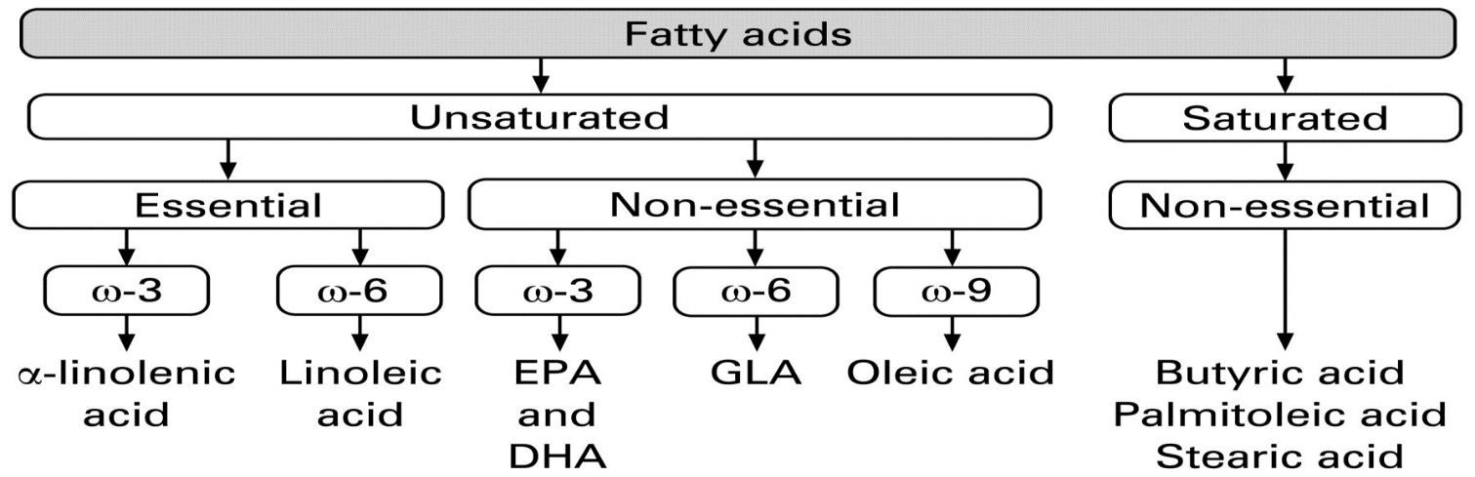

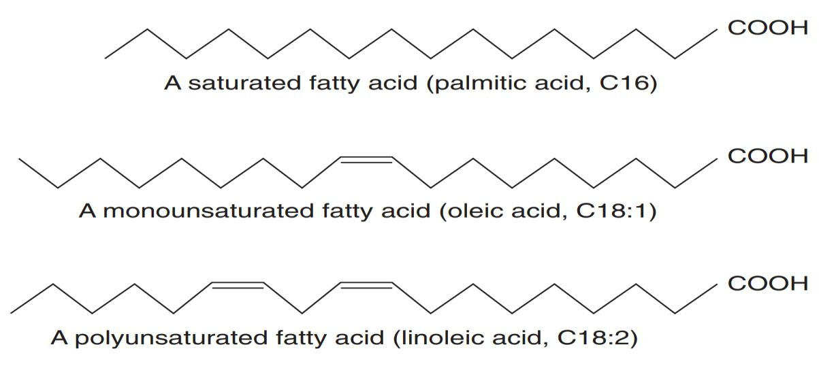

- Omega 3(ω3) – Long chain ω3 fatty acids such as α-linolenic (ALA) (found in plant oils), eicosapentaenoic (EPA) (found in fish oil) and docosahexaenoic (DHA) (found in fish and algal oils) have anti- inflammatory effects, perhaps due to their effects in promoting the synthesis of less inflammatory prostaglandins and leukotrienes as compared to ω6 fatty acids.

Triglycerides
Triacylglycerols (formerly triglycerides) are the esters of glycerol with fatty acids. The fats and oils that are widely distributed in both plants and animals are chemically triacylglycerols. They are insoluble in water and non-polar in character and commonly known as neutral fats.
Fats (solid at room temperature) and oils (liquid at room temperature) are complex mixtures of triacylglycerols whose fatty acid compositions vary with the organism that produced them. Plant oils are usually richer in unsaturated fatty acid residues than animal fats, as the lower melting.

Structural representation—
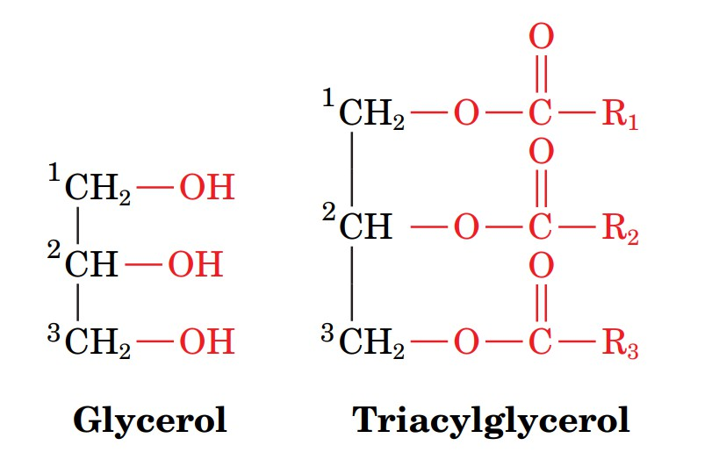

Properties of triglycerides—Triacylglycerols are less oxidized than carbohydrates or proteins and hence yield significantly more energy per unit mass on complete oxidation.
- Hydrolysis— Triacylglycerols undergo stepwise enzymatic hydrolysis to finally liberate free fatty acids and glycerol. The process of hydrolysis, catalysed by lipases is important for digestion of fat in the gastrointestinal tract and fat mobilization from the adipose tissues.
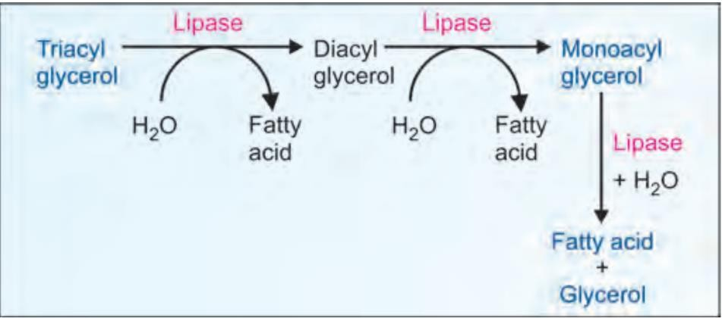
- Saponification— The hydrolysis of triacylglycerols by alkali to produce glycerol and soaps is known as saponification.
Triacylglycerol + 3 NaOH Glycerol + 3 R-COONa (soaps).

- Rancidity— Rancidity is the term used to represent the deterioration of fats and oils resulting in an unpleasant taste. Fats containing unsaturated fatty acids are more susceptible to rancidity. Rancidity occurs when fats and oils are exposed to air, moisture, light, bacteria etc.
- Lipid peroxidation— In the living cells, lipids undergo oxidation to produce peroxides and free radicals which can damage the tissue. The free radicals are believed to cause inflammatory diseases, ageing, cancer, atherosclerosis etc

Lipoproteins
Definition and compositions— Lipoproteins are molecular complexes of lipids with proteins. They are the transport vehicles for lipids in the circulation.
Classification of lipoprotein— Based on their separation by electrophoresis is classified in five major class.
- Chylomicrons (CM)— They are synthesized in the intestine and transport exogenous (dietary) triacylglycerol to various tissues. They consist of highest (99%) quantity of lipid and lowest (1%) concentration

of protein. The chylomicrons are the least in density and the largest in size, among the lipoproteins.
- Very low-density lipoprotein (VLDL)— They are produced in liver and intestine and are responsible for the transport of endogenously synthesized triacylglycerols.
- Low density lipoprotein (LDL)— They are formed from VLDL in the blood circulation. They transport cholesterol from liver to other tissues.
- High density lipoprotein (HDL)— They are mostly synthesized in liver. Three different fractions of HDL (1, 2 and 3) can be identified by ultracentrifugation. HDL particles transport cholesterol from peripheral tissues to liver (reverse cholesterol transport).
- Free fatty acids—Albumin— Free fatty acids in the circulation are in a bound form to albumin. Each molecule of albumin can hold about 20-30 molecules of free fatty acids. This lipoprotein cannot be separated by electrophoresis
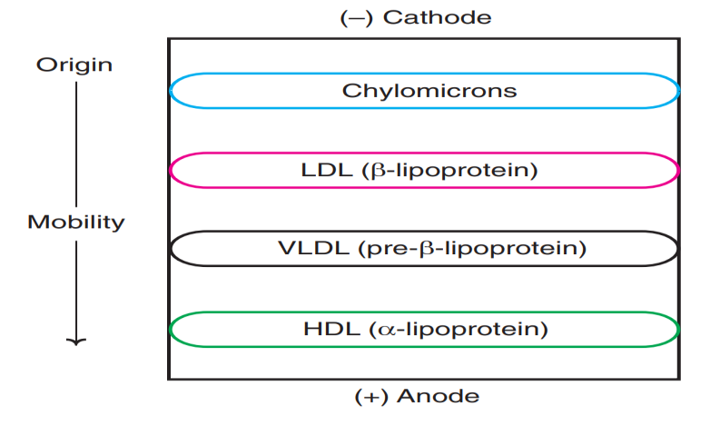

Electrophoresis of plasma lipoprotein Chart

Functions of Lipoprotein—
  - Lipoproteins deliver the lipid components (cholesterol, triacylglycerol etc.) to various tissues for utilization.
  - They function as transport vehicles for lipids in blood plasma.

Cholesterol
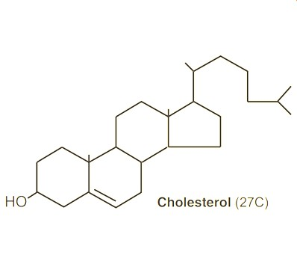
Definition and structures— Cholesterol is found exclusively in animals; hence it is often called as animal sterol. The total body content of cholesterol in an adult man weighing 70 kg is about 140 g i.e., around 2 g/kg body weight.
Cholesterol is amphipathic in nature, since it possesses both hydrophilic and hydrophobic regions in the structure. In healthy individuals, the total plasma cholesterol is in the range of 150-200 mg/dl.
Biosynthesis of cholesterol— About 1 g of
cholesterol is synthesized per day in adults. Almost all the tissues of the body participate in cholesterol biosynthesis. The largest contribution is made by liver (50%), intestine (15%), skin, adrenal cortex, reproductive tissue etc.
The enzymes involved in cholesterol synthesis are found in the cytosol and microsomal fractions of the cell. Acetate of acetyl CoA provides all the carbon atoms in cholesterol.
Cholesterol was first isolated from bile. Cholesterol literally means ‘solid alcohol from bile.’

Functions of Cholesterol—
  - It is the structural components of the cell, which maintain the stability and the metabolism of the cells.
  - Cholesterol is the precursor for the synthesis of all other steroids in the body. These include steroid hormones, vitamin D and bile acids.
  - It is an essential ingredient in the structure of lipoproteins in which form the lipids in the body are transported.
  - Fatty acids are transported to liver as cholesteryl esters for oxidation.

Qualitative tests of lipids

Solubility—
  - Solubility of Lipid in organic solvents depends on length of hydro- carbon chain of the fatty acids attached to glyceride.
  - Lipids are soluble in solvents like- Chloroform, ether, alcohol, hexane etc.

Formation of translucent spot-on paper/Spotting effects—
  - All the lipids are greasy in nature therefore the test may be taken as group test for lipids. So, take 3ml of ether in a test tube and dissolve 5 drops of oil in test tube.
  - The put a drop of the solution on the filter/ normal paper and let it dry.
  - A translucent spot on the filter paper observed and this indicates the greasy character of lipids.

Emulsification—
  - When oil or liquid fat is shaken with water. It is finely divided and is displayed in the water to form what is known as emulsion.
  - Shake a drop of oil with little water in a test tube. The oil becomes finally divided forming an emulsion.

Iodine absorption test.
  - This test is for unsaturated fatty acids for fat. A drop of iodine is added to fat (Fat some is prepared in chloroform) and shaken.
  - This solution will decolorize if unsaturated fatty acid is present.

Importance/functions of lipids
- It is the dietary constituents and provide the energy after metabolism, so we consider lipids a third major class of biomolecules.
- Lipids serve additional functions in the body, for example, some fat- soluble vitamins have regulatory or coenzyme functions, and the prostaglandins and steroid hormones play major roles in the control of the body’s homeostasis.
- Lipid also provide the hydrophobic barrier that permits partitioning of the aqueous contents of cells and subcellular structures.
- Fat is stored in adipose tissue, where it also serves as a thermal insulator in the subcutaneous tissues and around certain organs. Nonpolar lipids act as electrical insulators, allowing rapid propagation of depolarization waves along myelinated nerves.
- Lipids have essential roles in nutrition and health and knowledge of lipid biochemistry is necessary for the understanding of many important biomedical conditions, including obesity, diabetes mellitus, and atherosclerosis.

